**SFTP TO OBTAIN THE PCAP FILE:**

1. In the backtrack machine, open a command prompt and sftp to the ip address 128.238.66.35

The command is

**sftp studentid@128.238.66.35**

student_id is the VLAB username assigned to you.

When prompted enter the VLAB **password**.

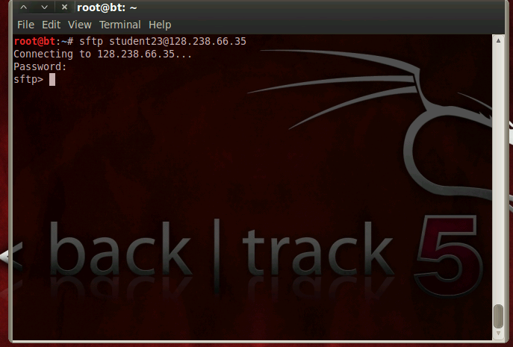

2. Once the sftp is successful, you will be in your student directory.

Enter **cd ..** to go one directory above in the tree.

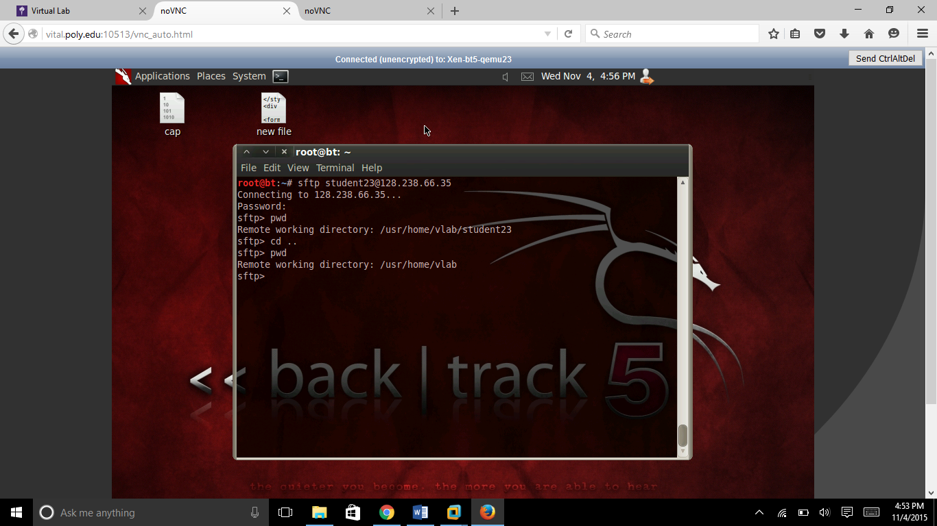

3. Then **CD CS6823** to navigate into the directory CS6823.

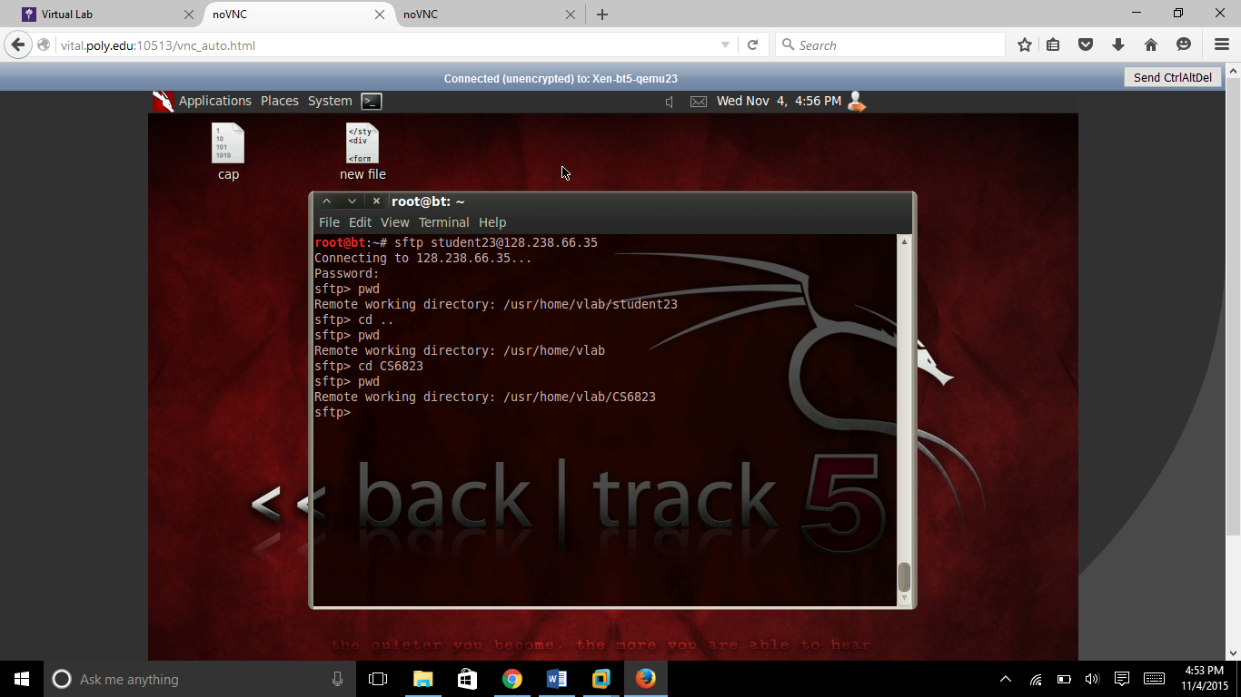

4. You then need to download the file infected.pcap into the backtrack machine.

Enter the get command as shown:

**get infected.pcap**

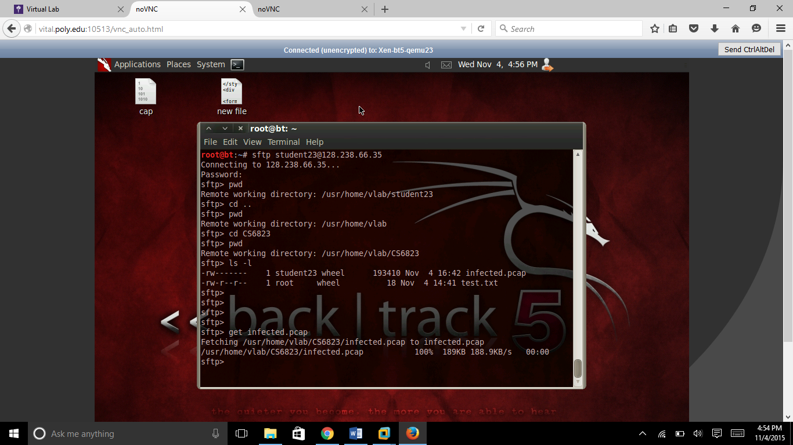

5. This will save the infected.pcap file onto the backtrack machine.

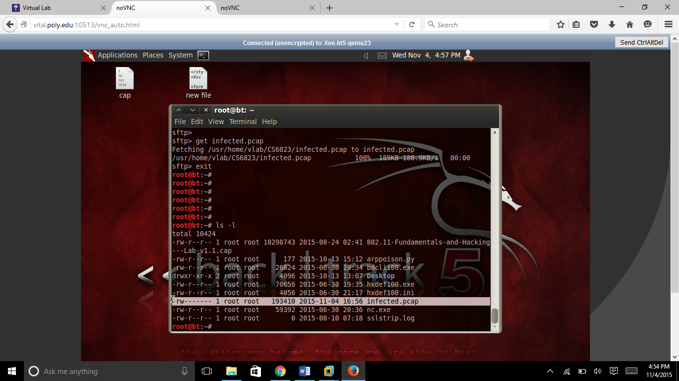

You will use this infected.pcap file for lab3.